**Preliminary Results**

We have found that participants of the DWD seminar exhibited decreased stress and burnout and enhanced resilience and well-being at all timepoints that followed the intervention (see Fig. 2). We observed a significant reduction in mean (SD) stress scores of (The Perceived Stress Scale (PSS-10);[(Lee 2012)](https://sciwheel.com/work/citation?ids=5267337&pre=&suf=&sa=0&dbf=0)) of the participants from baseline (C1) to 6-months (C5) after the intervention (C1 to C5: ____; p <.001). Stress decreased significantly immediately following the intervention and continued to decrease in the first month of follow-up, and remained stable between first and sixth month (p=). A similar trend was observed for burnout C1 to C5: (__ [__] vs ___ [___]; p < .001), including in its subscales of disengagement and exhaustion (p<0.01). Statistically significant differences from baseline were also observed in the mean scores for resilience (C1 to C5: (__ [__] vs ___ [___]; p < .001), with resilience continuing to increase in the first month followed the intervention, and then stabilizing between the first and the sixth month (p=).

All of the psychosocial factors: psychological well being (PERMA Profiler [(Butler and Kern 2016)](https://sciwheel.com/work/citation?ids=7044304&pre=&suf=&sa=0&dbf=0), quality of life (The World Health Organization Brief Quality of Life Index (WHOQOL-BREF-26; [(Anon n.d.)](https://sciwheel.com/work/citation?ids=15377076&pre=&suf=&sa=0&dbf=0)), gratitude (Gratitude Questionnaire (GQ-6, [(Mccullough et al. 2002)](https://sciwheel.com/work/citation?ids=3582408&pre=&suf=&sa=0&dbf=0)), self efficacy (General Self-efficacy Scale (GSE-10; [(Schwarzer 2012)](https://sciwheel.com/work/citation?ids=15377104&pre=&suf=&sa=0&dbf=0)), Professional fulfillment (Professional Fulfillment Index; PFI-16, [(Gustafson et al. 2023)](https://sciwheel.com/work/citation?ids=15093411&pre=&suf=&sa=0&dbf=0)) improved following DWD and continued to elevate during the first month of the follow-up, and most of them stabilized at the subsequent checkpoints, exhibiting a significant difference from baseline ( ).

Figure **1 (A)** Change in psychosocial variables presented in the graph as changes in Z-Scores (-2 to +2) from C1 (Baseline), C2 (post-DWD), C3 (one-month follow-up), C4 (3-month followup) to C5 (6 months follow-up). **(B).** Change in Burnout, Resilience, and Stress scores during the 6-month follow-up.

Using c-means clustering, four primary clusters of longitudinal trajectories were identified, delineating the early and late effects of DWD on stress and resilience (Figure 2A). Some participants experienced a decrease in stress following DWD, which remained stable after one month of follow-up (cluster 1), while others exhibited a transient post-DWD decrease before returning to baseline levels (cluster 2). The remaining participants presented a delayed decrease post-DWD but stabilized after one month (cluster 3), and others decreased immediately after the intervention and maintained this reduced level throughout the follow-up period (cluster 4). Analysis further unveiled a similar clustering pattern in participants' resilience trajectories, which appeared to inversely mirror the stress patterns noted above. Correlation networks will be generated for each cluster to find potential regulators of biological processes and novel molecular functions through unexpected connections. Longitudinal inverse correlation between stress and resilience of all participants ADD DATA (Figure 2B).

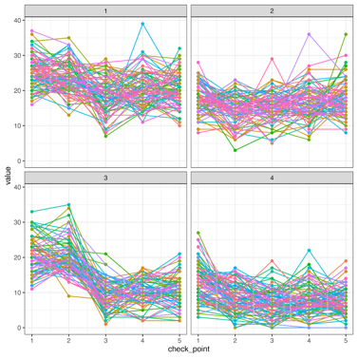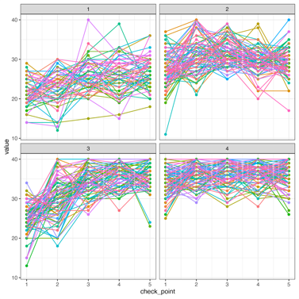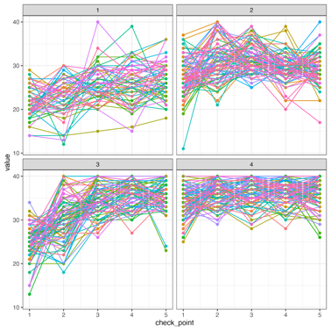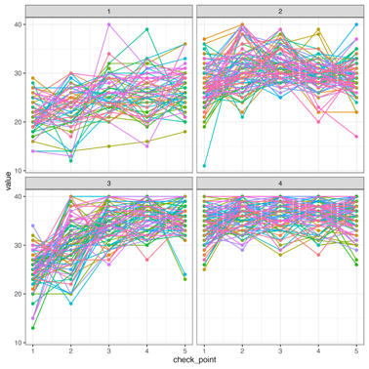

Stress

Resilience

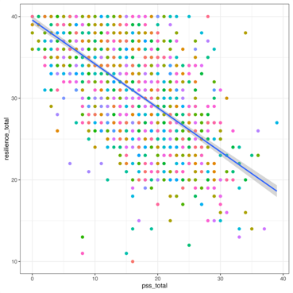

Cluster 1 Cluster 2 Cluster 3 Cluster 4

**Figure 3** (A) Using c-means clustering, four primary clusters of longitudinal trajectories were identified delineating the early and late effects of DWD on stress and resilience (B). Longitudinal correlation between stress and resilience.

EMA-based mood scores analysis (see Figure 3) revealed that higher stress (PSS-10) was correlated with worse mood levels in their daily life (r =ADD, p < 0.001), indicating a moderate to strong negative correlation (verify?). Inversely, higher resilience (CD-RISC10) was correlated with better mood levels in daily life (r = ADD, p < 0.001, indicating a moderate to strong (verify?) positive correlation.

A B

**Figure 4. EMAs and stress and resilience.** (A) Participants stress (PSS-10) was negatively correlated to mood levels in their daily life; (B) While participants resilience (CD-RISC-10), was positively correlated to mood in their daily life. ADD HOW CALCULATED.